Comms Software General Description:

# 2 transfer data transfer modes designed:

1. Image Acquisition Sequence
2. Onboard Computing Update Sequence

# Frames:

## Start I-Frame:

* Ground station transmits to satellite to Start Information Sending Frame that sets up parameters such as command for current transmission, maximum end transmission time, Next time to transmit
* Commands Include: Send image thumbnails, send specific image, apply Onboard Computing patch, capture image

## TT&C I-Frame:

* Frame transmitted by satellite containing Telemetry, Tracking, and Command data

Contains the following sensor information:

* OBC time
* GPS coordinates
* Sun Sensor Voltage + Currents
* Battery voltages
* Temperature Sensors
* Solar Panel voltages
* Magnetorquer current/volt
* Magnetic compass sensor

## Acknowledge S-Frame (ARQ)

* Supervisory frame used to transmit from the ground station to the satellite to acknowledge frames received and to request next action to be conducted

4 possible actions:

* Acknowledge send next frame
* Acknowledge do not send next frame
* Selective Reject a frame for retransmission
* Reject all frames, retransmit all

## VR camera I-Frame

* Information frame transmitting images from the satellite

2 modes to send images in varying qualities:

* Primary mode to send back 12 bit JPEG images at 3000x3000 pixels per image at 13.5MB
* Secondary mode sends back images with up to 15x compression <1MB per image using lower bit depth

## OBC(Onboard Computing) Update I-Frame

* Information frame transmitting from ground station up to satellite to update onboard computer or to fix if software bits corrupt and checksums are not complete
* Used in case error in software occurs and checksums are not satisfied or an error in software design is discovered

## End Transmission S-Frame:

* Supervisory frame used to transmit to the Satellite to end transmission at the end of a transmission sequence

# Image Acquisition Sequence:

## Diagram:

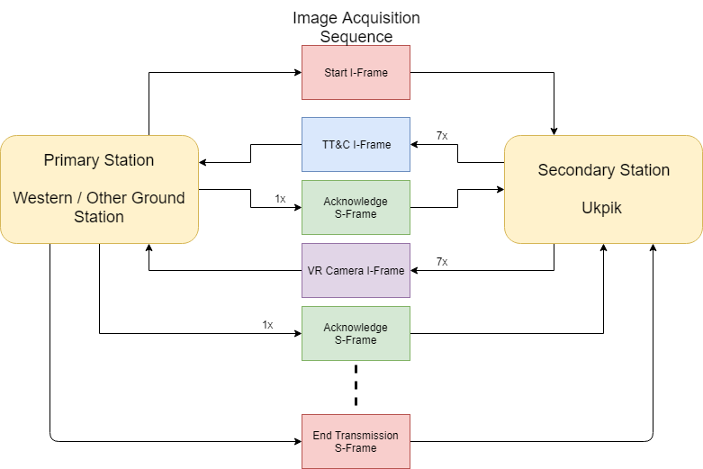

## Description:

1. 1x Start I-Frame transmitted from ground station to begin a communication sequence with an image transmission command (other functionalities work in similar manor)
2. 7x TT&C I-Frame transmitted from satellite to collect telemetry, tracking, and command data information
3. 1x acknowledge S-Frame transmitted from ground station to acknowledge received info and request next frame
4. 7x VR camera I-Frame transmitted by satellite to retrieve image data on the ground
5. 1x acknowledge S-Frame transmitted from ground station to acknowledge received info and decide what next action is based on the 4 possible actions provided in [HERE](#_Acknowledge_S-Frame_(ARQ))
6. IF “do not send next frame” request is received by the ground station through the Acknowledge S-Frame then ground station will transmit End Transmission S-Frame

# OBC Update Sequence:

## Diagram:

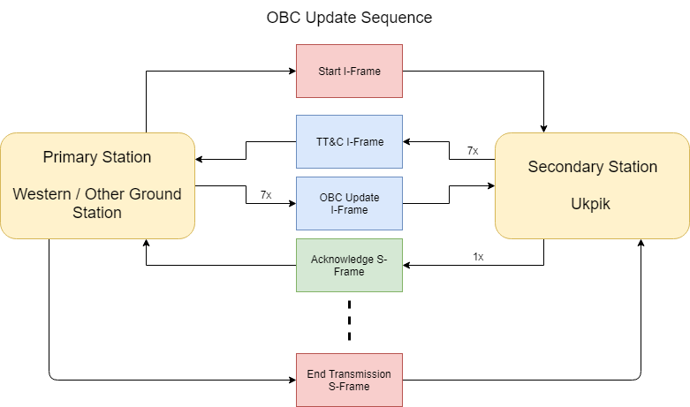

## Description:

1. 1x Start I-Frame transmitted from ground station to begin a communication sequence with OBC patch command
2. 7x TT&C I-Frame transmitted from satellite to collect telemetry, tracking, and command data information
3. 1x acknowledge S-Frame transmitted from ground station to acknowledge received info and request next frame
4. 7x OBC Update I-Frame transmitted by ground station to the satellite to provide data for OBC Patch
5. 1x acknowledge S-Frame transmitted from satellite to acknowledge received info and decide what next action is based on the 4 possible actions provided in [HERE](#_Acknowledge_S-Frame_(ARQ))
6. IF “do not send next frame” request is received by the ground station through the Acknowledge S-Frame then ground station will transmit End Transmission S-Frame